Lab 14

While in the lecture mark specified we should not have to pay to do this lab, so this made me think since I host me default information on my own server, I wanted to host this lab on a separate location and host it for free.

While googling around I got this result for the following search outputs came up from searching for free tor website hosting.

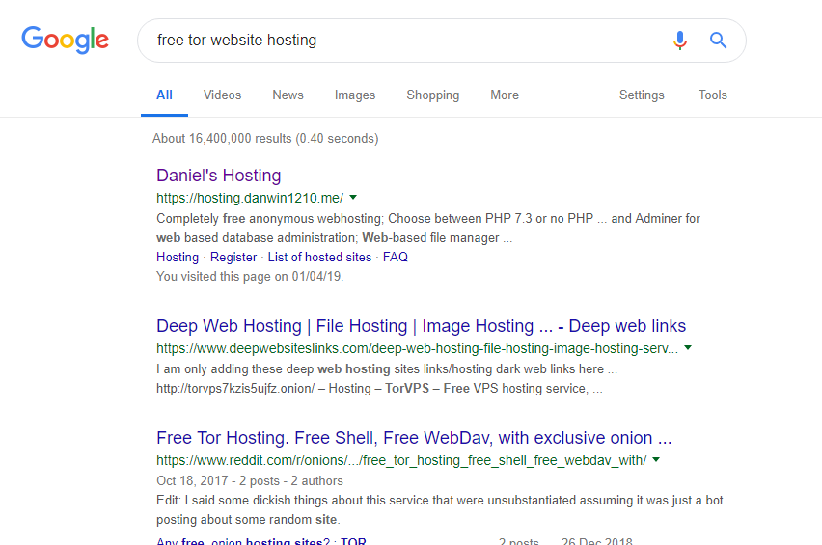

Checking Daniels website it seems he allows the free hosting of php websites while giving the user tor links for free, so I will build a simple website and host it through this site <https://hosting.danwin1210.me/>

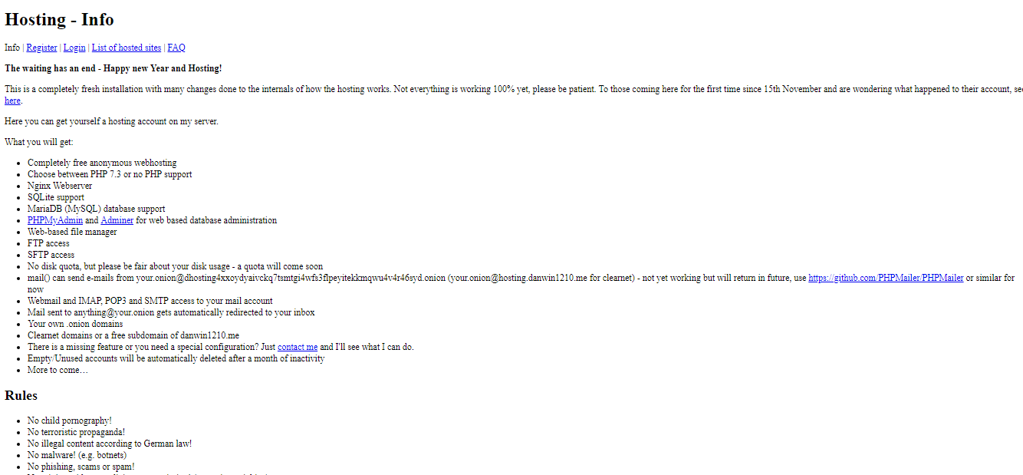

To attempt to make this website more anonymous I decided to set the account up through a vpn, for this we use Proton to connect them 10-minutemail for a temopary disposable email address.

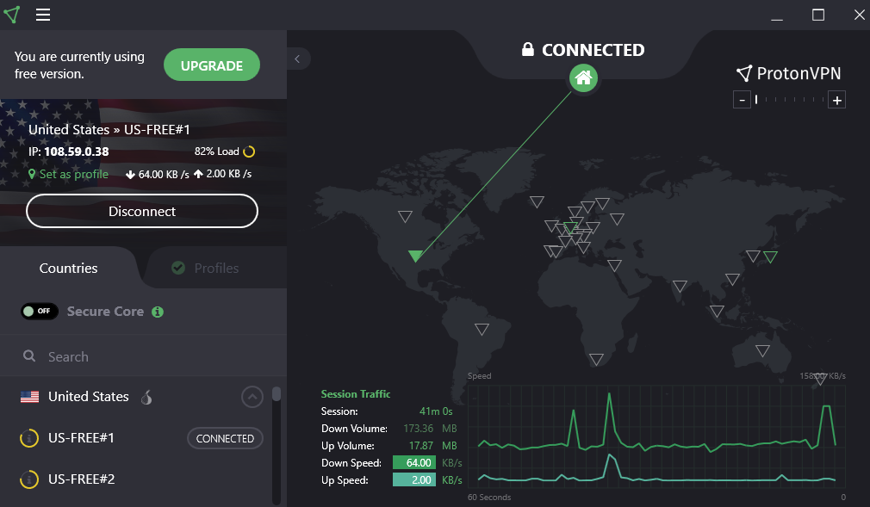

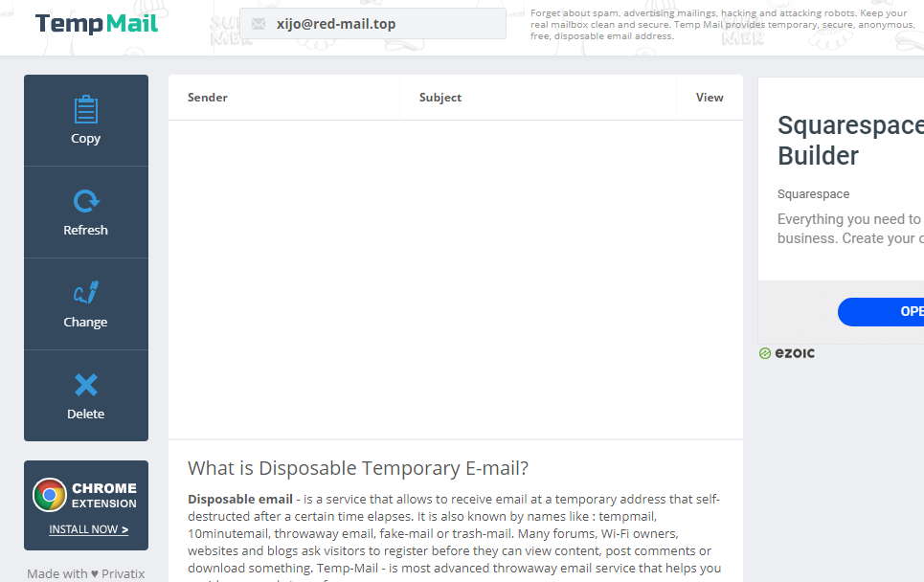

When fully registered

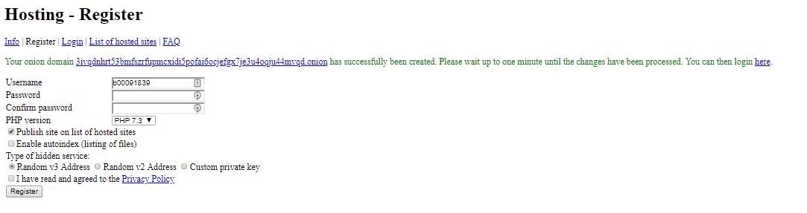

[3ivqdnhrt53bmfszrfupmcxidi5pofai6ocjefgx7je3u4oqju44mvqd.onion](http://3ivqdnhrt53bmfszrfupmcxidi5pofai6ocjefgx7je3u4oqju44mvqd.onion/)

Here is the admin panel

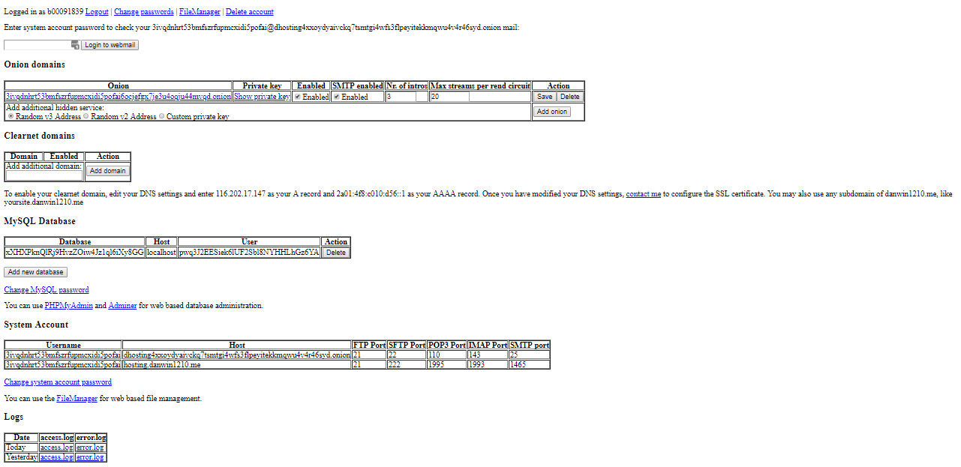

The upload portal looks like this

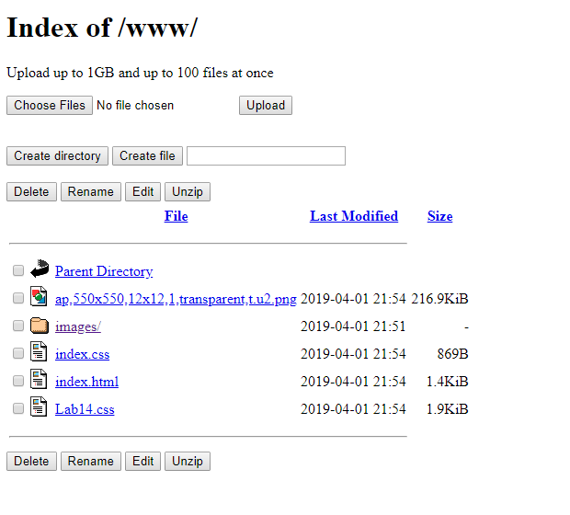

And uploading the site to the domain we can see it over tor

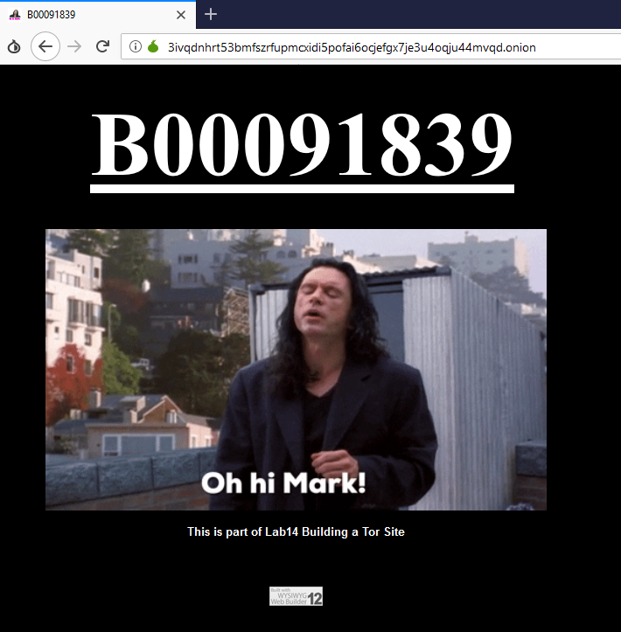

And can be viewed only over tor with the following link

[3ivqdnhrt53bmfszrfupmcxidi5pofai6ocjefgx7je3u4oqju44mvqd.onion](http://3ivqdnhrt53bmfszrfupmcxidi5pofai6ocjefgx7je3u4oqju44mvqd.onion/)